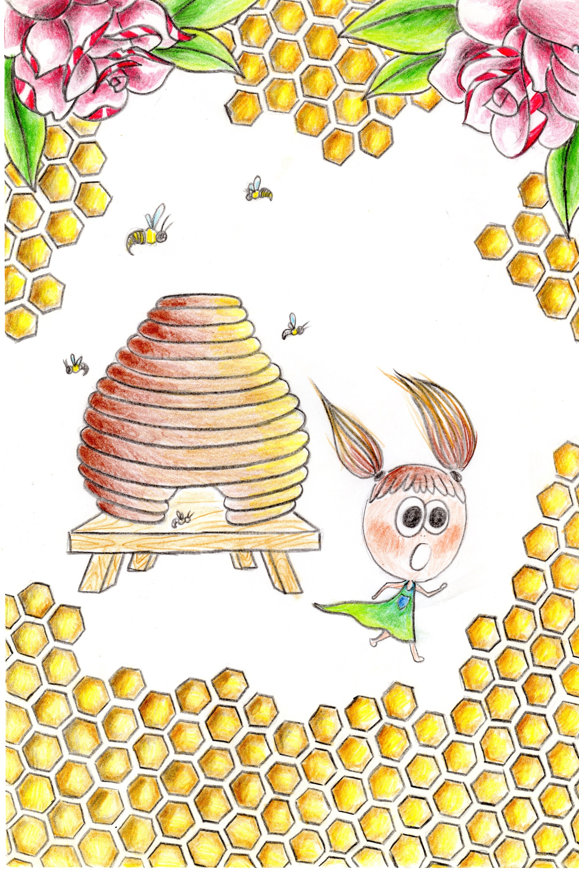

Kasper is so proud of the honey they make during the summer. Everything that her big brother knows, Alma wants to know too… and a bit more!

– Mummy, Mummy. There is a bee in my hair! It sounds angry**! M u m m y! HELP!**

– But Alma, stay calm! I´m coming. Don´t touch it!

– Mummy! Help!

It,s Alma who shouts after her Mummy,s help. Alma stands beside her grandma´s beehive. The beehive is shared between Grandma and Kasper who is Alma´s big brother. But n o w Alma wants to be with them. She w a n t s to see how honey is made in the hive.